

CSE370 : Database Systems
Project Report
Project Title : MangaPitch

Group No : 02, CSE370 Lab Section : 11, Spring 2026
ID | Name | Contribution
24101225 | Rahib Kibria Choudhury | Feature Implementation, Database creation and scraping data from API,  Branch merge and compatibility check
24101026 | Tadline Kabir | 2 Feature Implementation, Schema and Normalization
24101224 | Joy Kumer Tarafder | Frontend Design,  2 Feature Implementation, EER Diagram

Table of Contents

Section  No | Content | Page No
1 | Introduction | 3
2 | Project Features | 3
3 | ER/EER Diagram | 4
4 | Schema Diagram | 5
5 | Normalization | 6
6 | Frontend Development | 7
7 | Backend Development | 8-9
8 | Source Code Repository | 10
9 | Conclusion | 10
10 | References | 10

Introduction

Our project, MangaPitch builds connection between manga artists and the studios. A platform for mangakas to manifest and bring their art to life. Mangakas can showcase their works and open them up for competitive studio bids in a fair and structured environment. Every bid placed on manga remains strictly confidential. Studios cannot see each other’s offers which ensures an unbiased and competitive process. Only admin and the respective mangaka have access to view bid details for their listed works.

Project Features

ID,  Name | Features [3 per member]
24101225, Rahib Kibria Choudhury | Ft 1 | Multi User roles for Admin, Mangaka and Animation studios
 | Ft 2 | Manga portfolio(uploads of manga specifications) and pitch (description of story, genre etc)
 | Ft 3 | Bidding system for license (undisclosed amount for contract per studio )
24101026, Tadline Kabir | Ft 1 | Analytic and metric tracking
 | Ft 2 | Search filtering options (Most Viewed, Genre etc.)
24101224, Joy Kumer Tarafder | Ft 1 | Contract and Current status (Production status tracker)
 | Ft 2 | Direct messaging and negotiation (Role-based access)

ER/EER Diagram

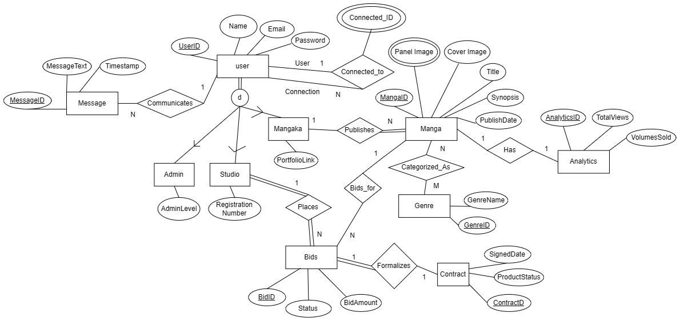
Schema Diagram

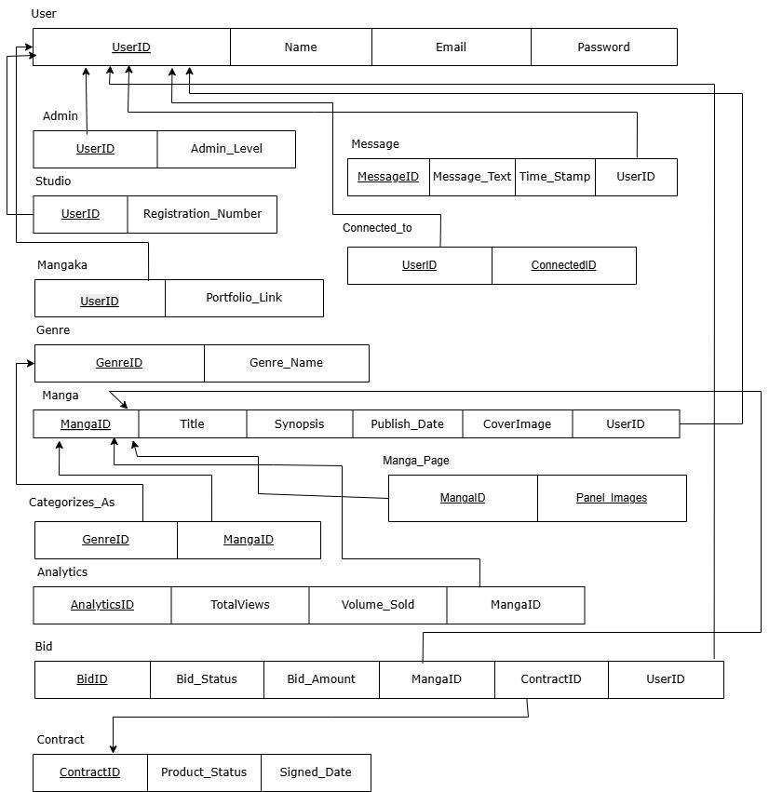

Normalization

- Explain if your converted Schema is in 1NF or not. If not, decompose it to 1NF.
Answer: The converted schema satisfied First Normal Form. All attributes across every relation contain atomic, indivisible values. There are no repeating groups or multivalued attributes. Each table has a defined primary key and every cell holds a single value. Therefore, the schema is in 1NF without requiring further decomposition.

- Explain if your converted Schema is in 2NF or not. If not, decompose it to 2NF. Can there be any partial functional dependencies in your relational schema?
Answer: The converted schema satisfies the Second Normal Form. The only relations with composite primary keys are the junction tables Categorizes_As, Connected_to and Manga_Page. None of them contain non-key attributes. All remaining relations have single attribute primary keys.Therefore, no partial dependencies exist and the schema is in 2NF.

- Explain if your converted Schema is in 3NF or not. If not, decompose it to 3NF. Can there be any transitive dependencies in your relational schema?
Answer: The converted schema satisfies Third Normal Form. In every relation, all non-key attributes are directly and solely dependent on the primary key and not dependent on any other non-key attribute. Therefore, no transitive dependencies exist and the schema is in 3NF.

Frontend Development

Contribution of ID : 24101225, Name : Rahib Kibria Choudhury

The frontend uses a comic-inspired aesthetic across its core tools to provide a manga page (off-white color and rock salt font) like visual. Dashboard organizes role-specific data using responsive flexbox grids, highlighting key metrics in bold summary cards. The upload feature includes a user-friendly HTML form for entering manga data, paired with custom file inputs and an interactive image grid with a lightbox to easily manage cover art and up to 5 story panels. Finally, the bid interface offers a submission system where studios select available titles via searching and enter financial offers, guided by contextual input placeholders and clear visual alert banners for successful or failed transactions. Further production progress control by admin aesthetics allow to track which phase of production the project currently is in after bid.

Contribution of ID : 24101026, Name : Tadline Kabir
Search page renders a search form with a text input, genre dropdown and sort selector. Results display in a card grid showing manga title, author, genres, synopsis, view count, volumes sold and a Bid button visible only to Studio users. Live search is handled via debounced JS (300ms) that fetches and & ajax=1 and updates the results container and count-in-place without page reload and refocuses the input after each update.
The analytics page has an Admin only stat panel showing platform total views and volumes sold. Below is a table with manga title, mangaka name, genres, publish date, total views, volumes sold. The mangaka name column is hidden when the logged-in user is a mangaka. The mangakas can only see his own manga’s publish date, total news and volume sold.

Contribution of ID : 24101224, Name : Joy Kumer Tarafder
The frontend is built with HTML for structure and CSS through style.css for styling. For the dynamic parts, plain JavaScript in main.js takes care of things like auto-resizing text areas, making flash messages disappear after a few seconds, showing timestamps line “2 may 2026, 3:09 pm” and highlights the current page in the nav. There’s also some online JS inside the messages index.php that polls poll.php every 3 seconds using fetch() to load new messages and add them to the chat without refreshing the page.

Backend Development

Contribution of ID : 24101225, Name : Rahib Kibria Choudhury

Added the following components described below:
Mangapitch comprises three types of roles to determine specific landing pages after login: admin, mangaka, and studios through targeted SQL queries.

Admin: Uses subqueries and JOINs to aggregate platform-wide statistics (user count, total views) while also being able to message anyone on the platform and move along production progress for a contract that has been accepted

Mangaka: Uses LEFT JOINs to display personalized portfolios of the mangakas with manga performance metrics, active bids.

Studio: Uses correlation subqueries to track active bids to be accepted/rejected or already accepted and JOINs to monitor the production status of finalized contracts.

As a mangaka you are able to upload your manga with the cover being limited by 1 and chapter panels as samples being limited to 5 (with 5MB limit per image). The system relies on PDO database transactions to guarantee ACID compliance; it inserts manga data, links multiple genres via junction table and initializes a new analytics tracker, rolling back the entire process if any single step fails. Post-upload panel or cover edits are done by safely unlinking the old images and deleting them before adding the new image connection and updating the database’s JSON-encoded panel array while making sure the 5 quantity of panels is maintained.

Finally, the bidding backend uses secure PDO prepared statements to safely manage the submission and modification of undisclosed licensing offers. For animation studios, the system dynamically populates the available manga selection by executing a subquery that actively filters the title where the studio already holds accepted contracts. During form submission, the backend validates financial data against existing records. The system also successfully updates the higher bid made by the same user for the same studio with pending showing only once for the user with the updated bid (UPDATE for the same user, INSERT for other users placing bid for the first time).

Contribution of ID : 24101026, Name : Tadline Kabir

In Search, it authenticates the user, then builds dynamic PDO prepared query joining Manga, Users, Analytics, Manga and Genre. A LIKE clause and genre subquery filter are appended conditionally based on inputs. The sort parameter is validated against a whitelist mapped to safe column names to prevent ORDER BY injection. When & ajax=1 is present, it skips full page rendering and returns a JSON object containing result count text and server-built HTML string.

The analytics page runs one of three queries depending on role such as Admin gets all manga platform-wide. Mangakas get only their own titles and Studio gets only mangas they have bid on. A separate aggregation query runs only to sum TotalVies and VolumesSold across the Analytic table. Both pages use GROUP_CONCAT to combine genre names per manga row and PDO prepared statements throughout.

Contribution of ID : 24101224, Name : Joy Kumer Tarafder

On the backend, PHP handles all the logic with a MySQL database. Database queries go through PDO which uses prepared statements to keep things safe. Users stay logged in through sessions and auth_guard.php checks their roles- Admin, Studio, Mangaka to control what they can see and do. Here, send.php saves new messages to the database, poll.php sends back new messages as JSON for the frontend to pickup and the contracts index.php lets admins update production status. Any user input is either cast to an integer or validated before touching the database to avoid SQL injection.

Source Code Repository

https://github.com/Rahib50/mangapitch

Conclusion

MangaPitch demonstrates how a thoughtfully designed database system can create a fair and transparent marketplace for manga creators and studios alike especially for mangakas and studios who are less mainstream and allow them to make something that may leave a mark on the industry. The sealed-bid model that is combined with role-based access control ensures data privacy and equal competition among the bidders. MangaPitch stands as a practical solution that bridges creative talent with commercial opportunity in the ever growing manga industry.

References

Learn PHP the right way (Program With Gio) [link]
Design inspiration: codecademy [link]
Aniwave [Free anime streaming website taken down recently]
Idea inspiration:
- Build an Anime Streaming Website | HTML CSS JavaScript Project for Beginners 2025 [link]
- Free API to scrape populating data for database: MyAnimeList
- Jikan (MyAnimeList API) [Link]

Google Fonts (for Rock Salt font) [link]
AJAX implementation : [link]
Engine : InnoDB

